Aufgabe: Palindrom

# Struktogramm

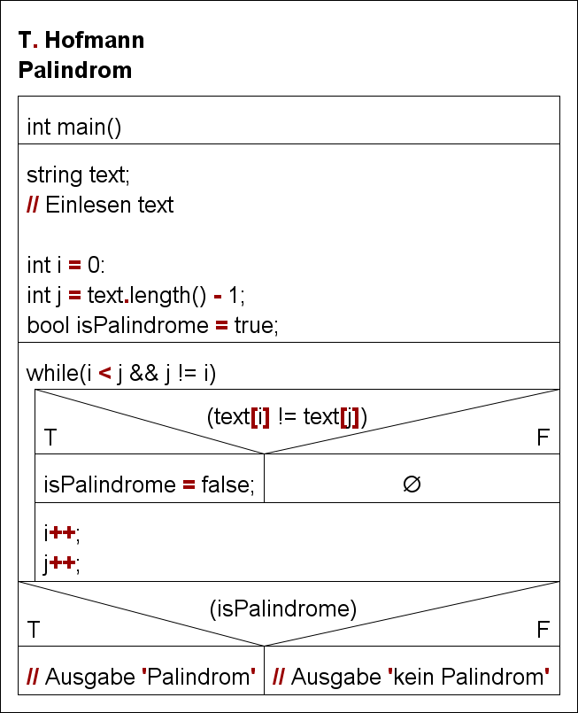

# Schreibtischtest

text = „ANNA“;

|  |  |  |  |  |  |  |  |
| --- | --- | --- | --- | --- | --- | --- | --- |
| i | text[i] | j | text[j] | while | if(text[i] != text[j]) | isPalindrome | if(isPalindrome) |
| 0 | A | 3 | A | T | F | T | - |
| 1 | N | 2 | N | T | F | T | - |
| 2 | N | 1 | N | F | - | T | T |

text = „RELIEFPFEILER“;

|  |  |  |  |  |  |  |  |
| --- | --- | --- | --- | --- | --- | --- | --- |
| i | text[i] | j | text[j] | while | if(text[i] != text[j]) | isPalindrome | if(isPalindrome) |
| 0 | R | 12 | R | T | F | T | - |
| 1 | E | 11 | E | T | F | T | - |
| 2 | L | 10 | L | T | F | T | - |
| 3 | I | 9 | I | T | F | T | - |
| 4 | E | 8 | E | T | F | T | - |
| 5 | F | 7 | F | T | F | T | - |
| 6 | P | 6 | P | F | - | T | T |

text = „TEST“;

|  |  |  |  |  |  |  |  |
| --- | --- | --- | --- | --- | --- | --- | --- |
| i | text[i] | j | text[j] | while | if(text[i] != text[j]) | isPalindrome | if(isPalindrome) |
| 0 | T | 3 | T | T | F | T | - |
| 1 | E | 2 | S | T | T | F | - |
| 2 | S | 1 | E | F | - | F | F |